**Project Preliminary Report**

* **Overview**

The purpose of this project is to build a system that can effectively and accurately handle and manage the activities involved in a library. In this project, less staff management, simple accessibility to search, and user profile management are major objectives.

* **Problem Statement:**

• Libraries are used to store books, but require a system to

navigate to a specific book or specific content within a book.

A library database system is an infrastructure that allows users

to search books and book content, add/remove, and download

selected books.

• The problem faced is that library users require an efficient

method to find a specific book or keywords within a book

given a continuously expanding library. Efficiency requires that

the processing time should stay relatively the same even as the

library contents increase.

* **Main Idea**

Following are the main points/goals of this program:

* Build a framework that can replace the management system of the manual library.
* Build a database that stores details of users and books.
* Provide users with relevant search facilities.
* There should be logins for the administrator or librarian.
* Creating a user-friendly experience that is easy to understand.
* Attractive user interfaces for users to work through the system.
* **Existing Solutions**

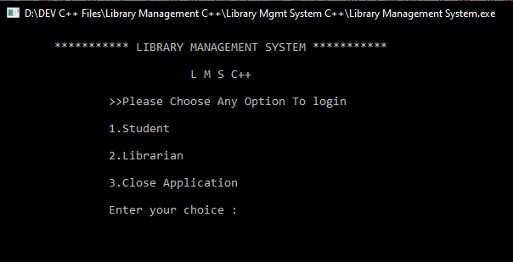

Student Portal:

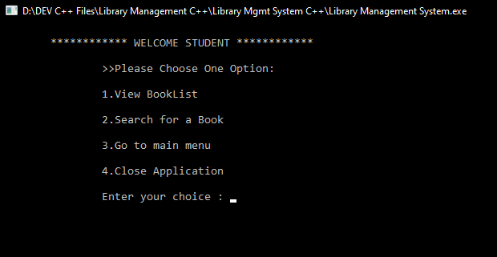

Booklist:

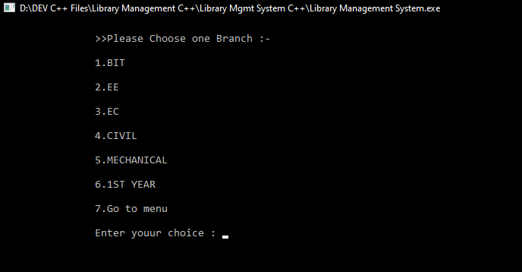

Librarian:

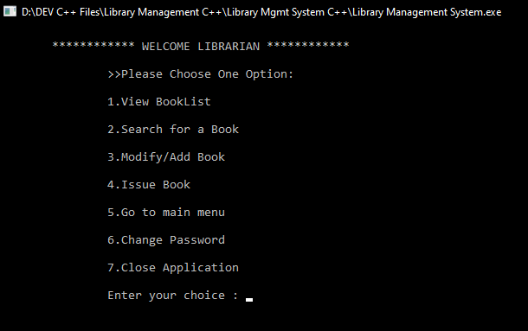

* **Class diagram**

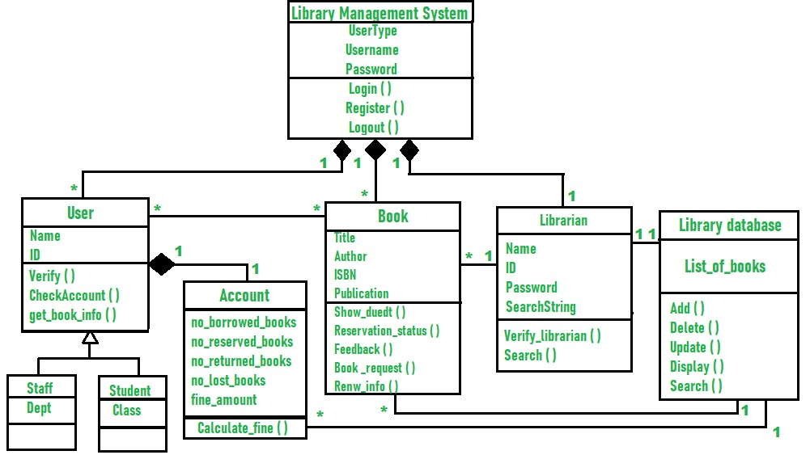

* **Covered topics will be:**
* Data abstraction
* Encapsulation
* Constructors
* Member initializer list & constant
* Static members and functions
* Inheritance
* Polymorphism
* Abstract classes & Interfaces
* File handling and GUI